How to use Zabbix PDF & Excel Export

- You need to extract and paste the folder into your Zabbix installation, typically located at /usr/share/zabbix/.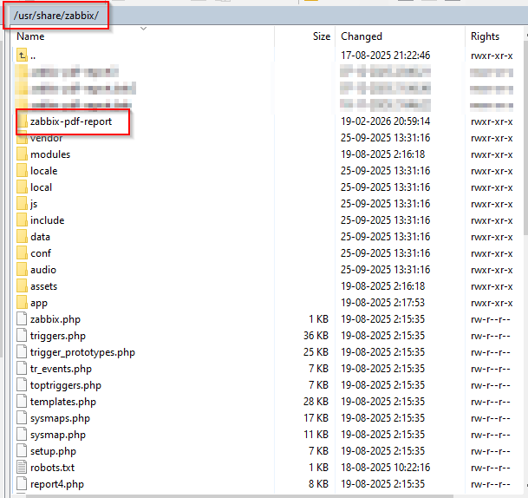
- Once the project has been extracted, you must modify the IP address in the config.php file, which is located inside the zabbix-pdf-report folder. Once you have located the file, change it to your IP address.
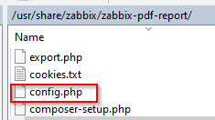
NOTE: Remember to assign a user for the API to interact with. This user must be created inside Zabbix (Frontend).
- Once the users have been created, go to http://your-ip-or-domain/zabbix/zabbix-pdf-report/. On this page, you can select the language and theme.
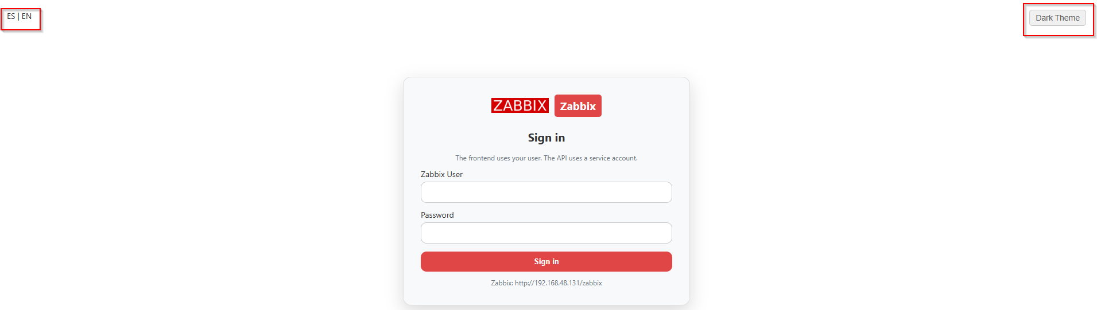
- After logging in, the following screen will appear. Here you must select either a list of hosts or host groups (DO NOT SELECT HOSTS AND HOSTGROUPS SIMULTANEOUSLY). You also need to select the type of item you want to graph and the corresponding date range.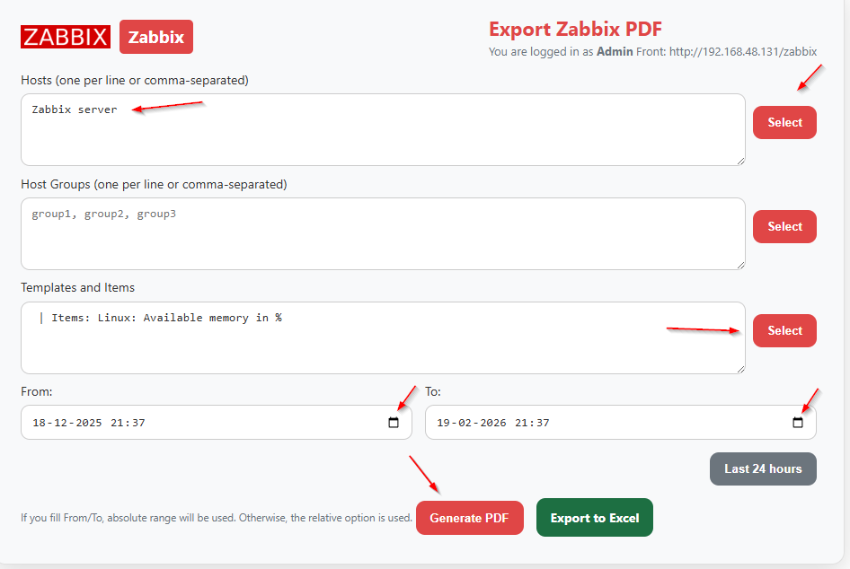
- To select templates, we recommend doing it by groups (especially if there are many devices), as this makes it easier to find what you need when the list expands. For example, for Linux servers, it will be easier to find the item memory → Linux available mem belonging to the target host, avoiding discrepancies with communication devices such as switches or routers. If you are selecting host by host, make sure you know the system type to find the correct item.
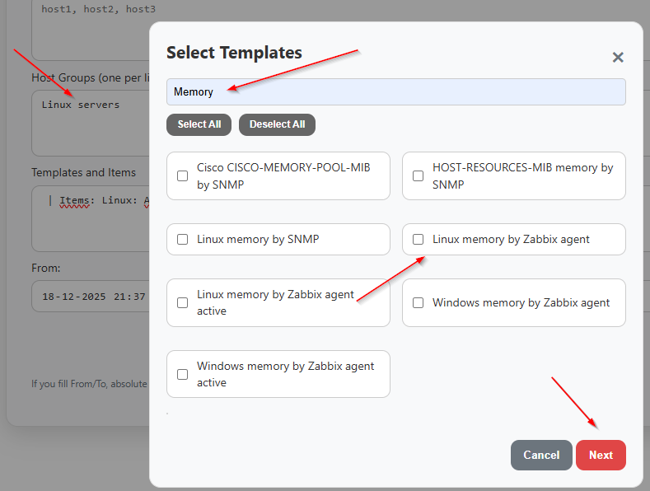
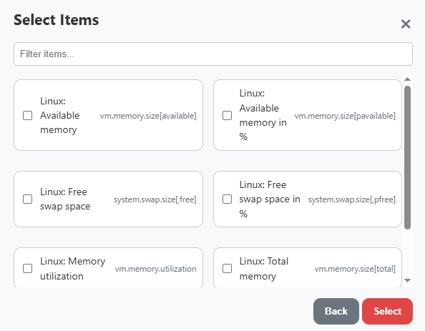
Once finished, select the corresponding item and generate the PDF.
- Export Excel. In this section, you will find different types of reports:.

- General Host List: Extracts the complete list of all hosts in Zabbix.
- Detailed Host Inventory: Here you can extract important data such as "Uptime", "DISKS", and "MEM". (Usage is similar to PDF Export). Certain parameters use tags: "Responsible Area", "Location", and "Device Type". If you want to keep things well organized, these three parameters will help you.
- Problem Report: Allows you to extract the complete list of active alarms in Zabbix.
- Peaks Report (CPU/MEM): Shows the number of servers with high memory and CPU consumption, at what time the peak occurred, and whether it is recurring.

- SLA Report. Usage is the same as the ZPDF Report. Here you can select the desired SLA target and either view it on screen or export it.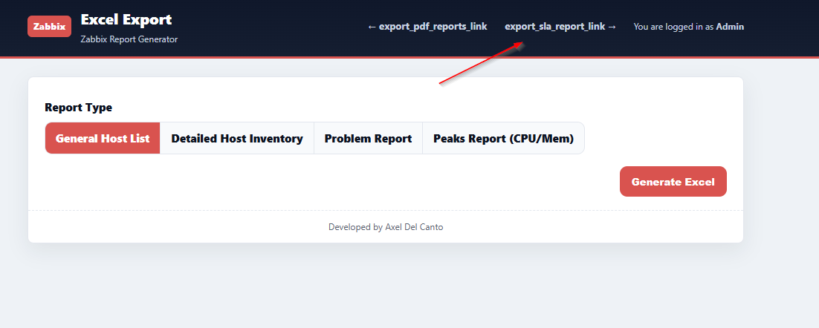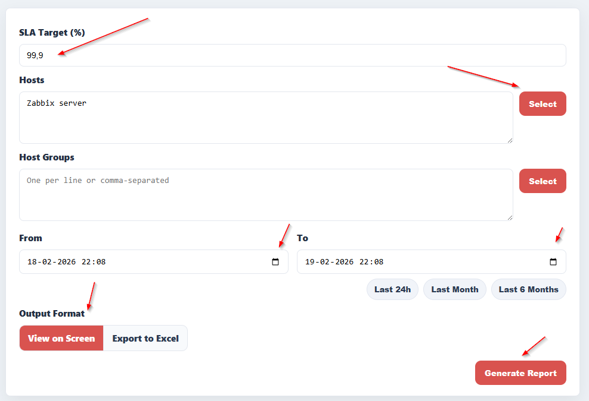
This section shows whether the SLA target is met or not, and also explains the reason for non-compliance, mentioning the problem that occurred and the duration of the event.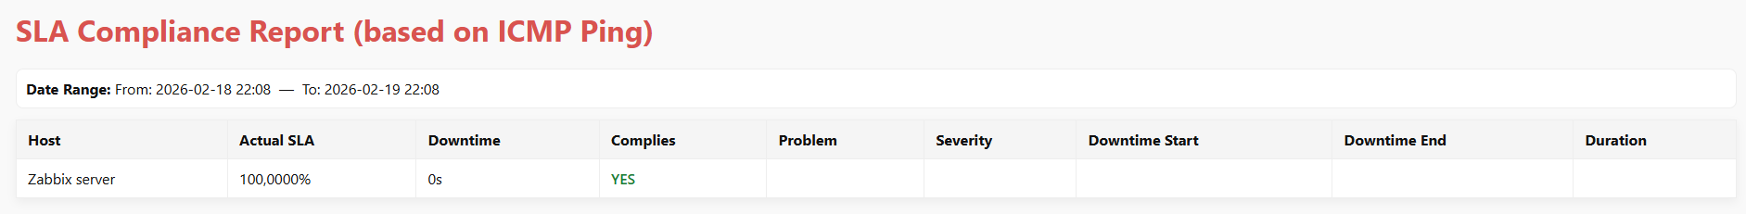
- This tool allows you to manage maintenance periods in Zabbix easily and intuitively, without needing to access the frontend directly or manually create maintenance windows.
Features:
- View active, future and expired maintenances
- Create new maintenances with custom periods
- Add hosts to existing maintenances
- Export host list to CSV
User permissions:
- Type 1 (User): Read-only
- Type 2 (Admin): View and create maintenances
- Type 3 (Super Admin): Full control
- Highlight: Smart host resolution that automatically groups related servers (e.g., SRV-WEB-01, SRV-WEB-02) even with different domains or suffixes.
